Tutorial for MonkeyRunner and Android GUI Testing

1. Download Android Studio
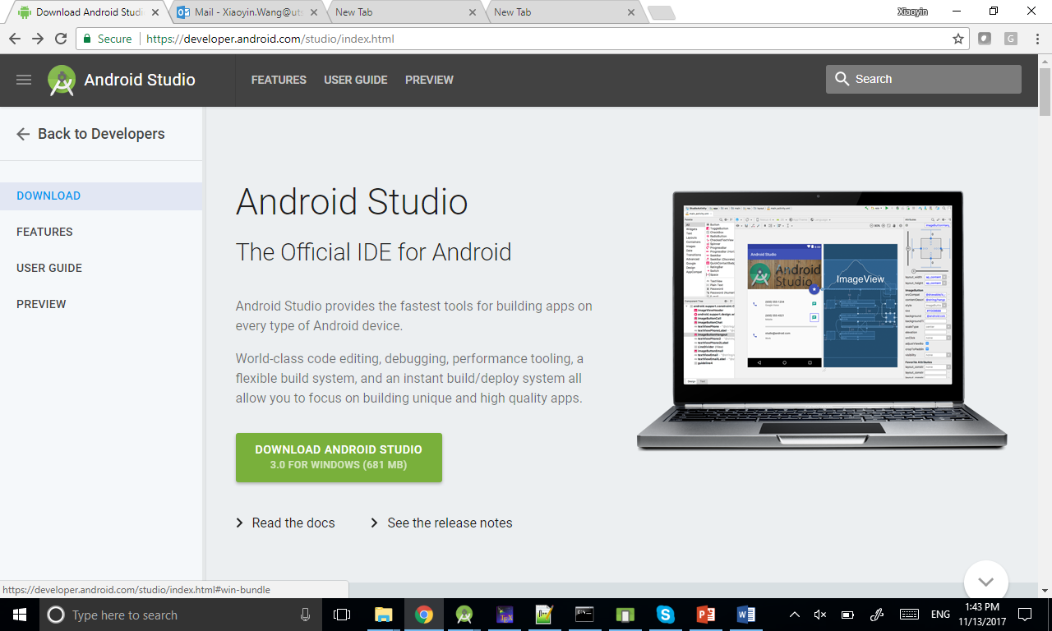

2. Start Android Studio

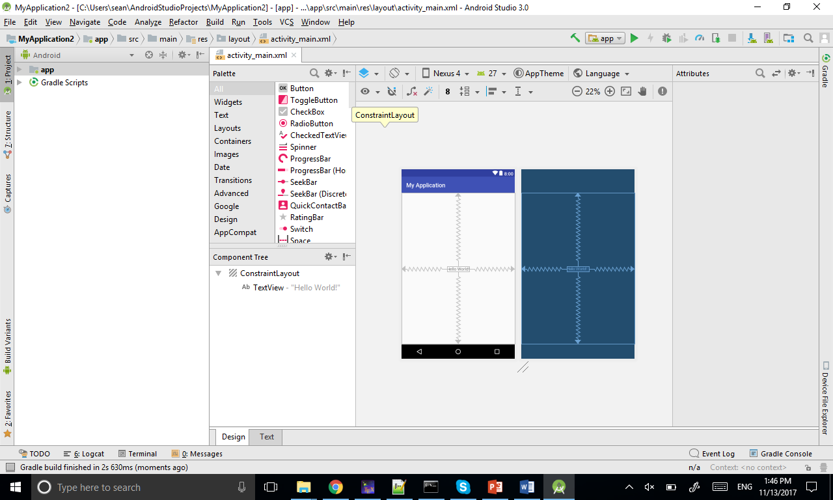

3. Open AVD Manager

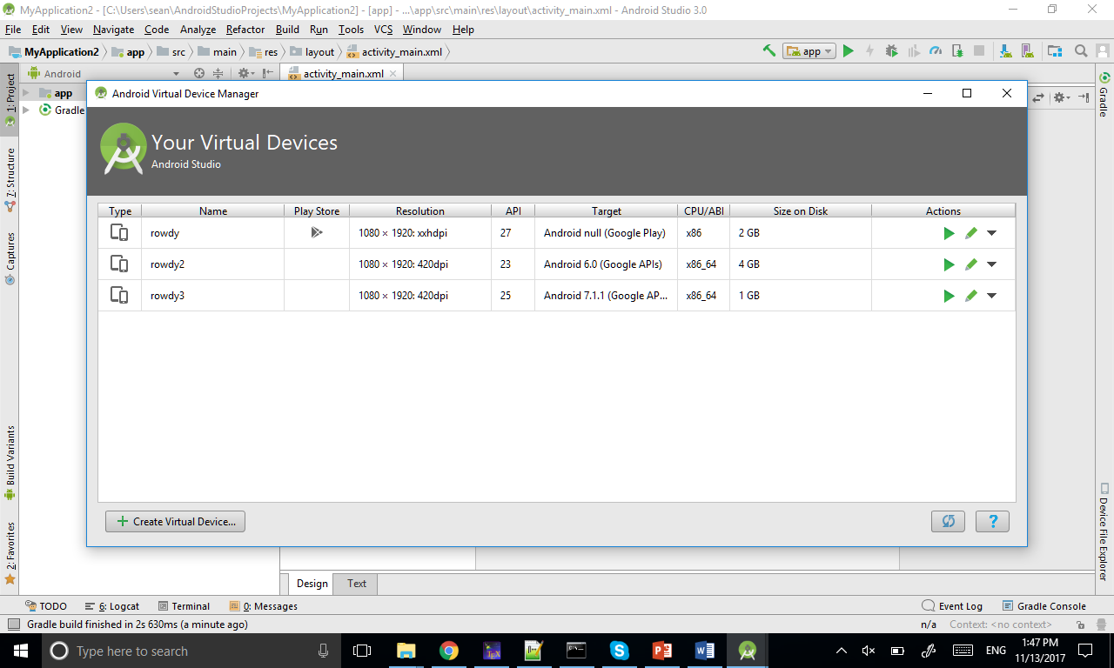

4. Create Virtual Device and select Pixel 2 1080*1920 (Pixel and Nexus 5 should also work if you do not have Pixel 2 option)

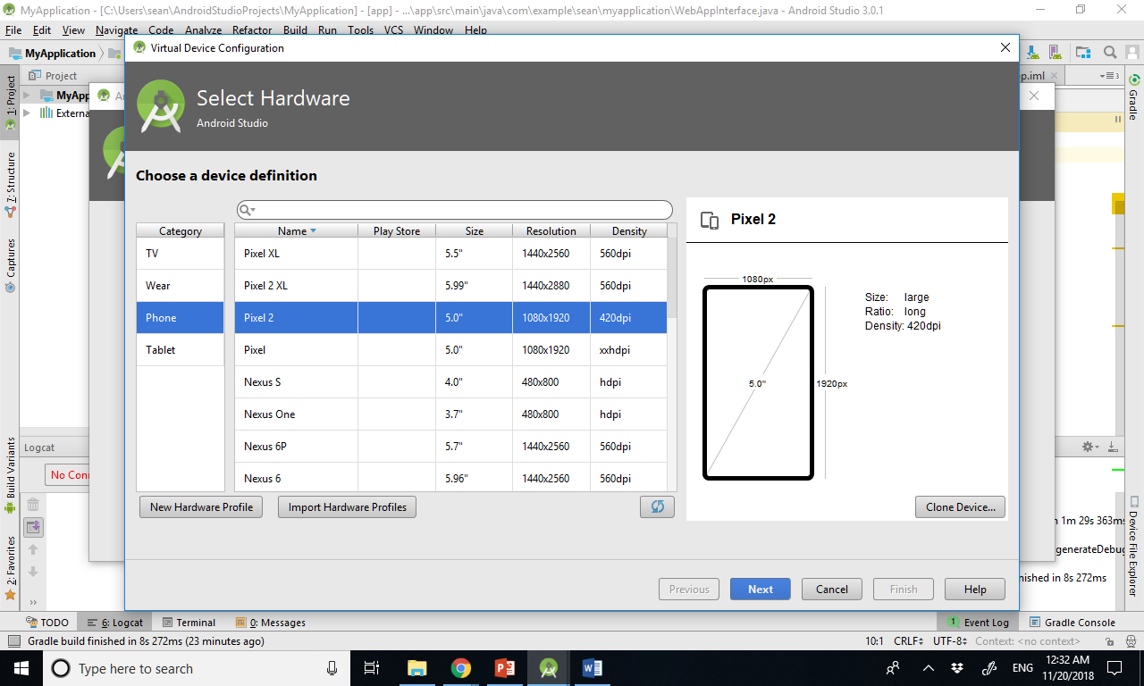

5. Go to x86 Images and choose Nougat API 25, x86_64, you may need to click on the blue Download if you do not have it. It may take 20 minutes.
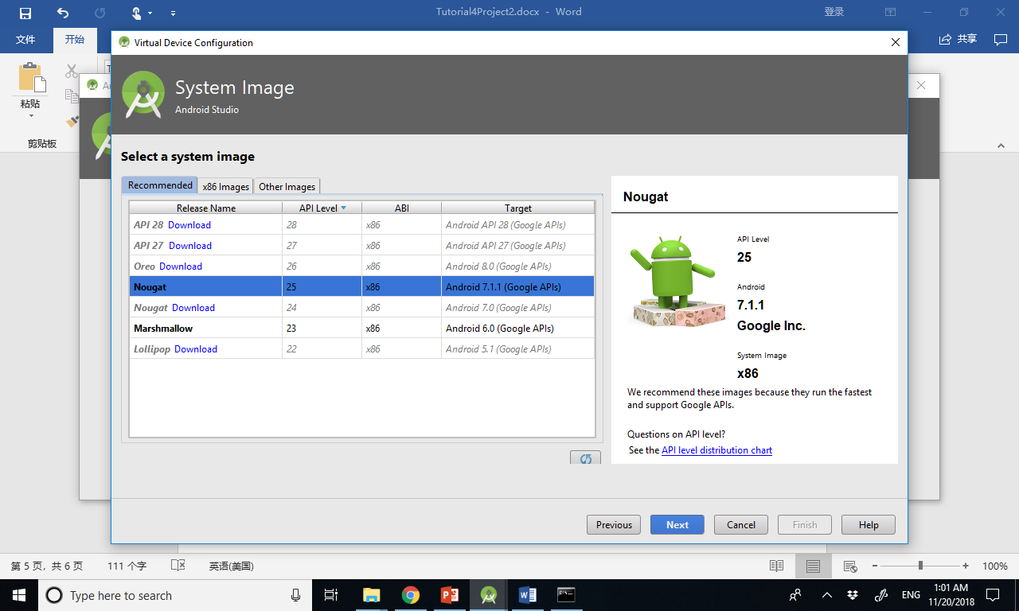

6. Give a name to the AVD

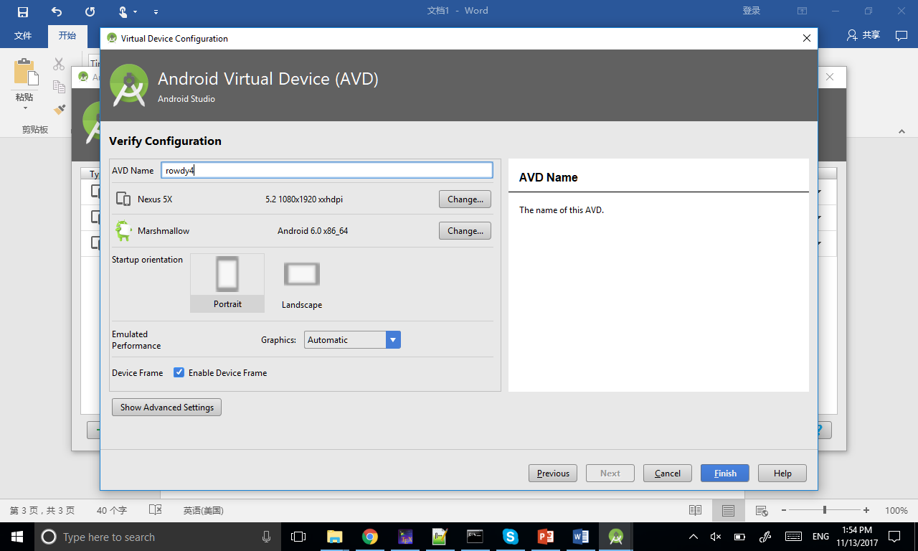

7. Click on the play button and the emulator should start

8. Go to settings, about emulated device, and click on the last item for 7 times, to become a developer

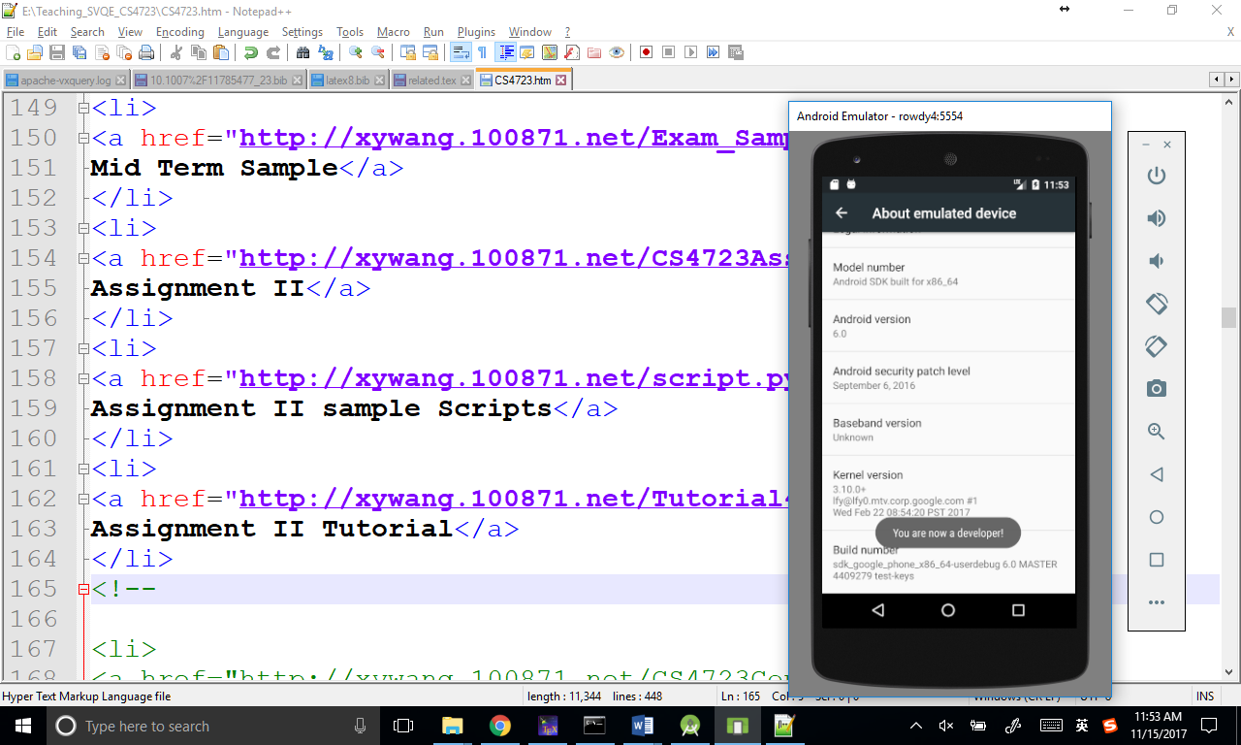

9. Go back on level, and now you can see a new item called Developer options. Go into it and enable Pointer Location

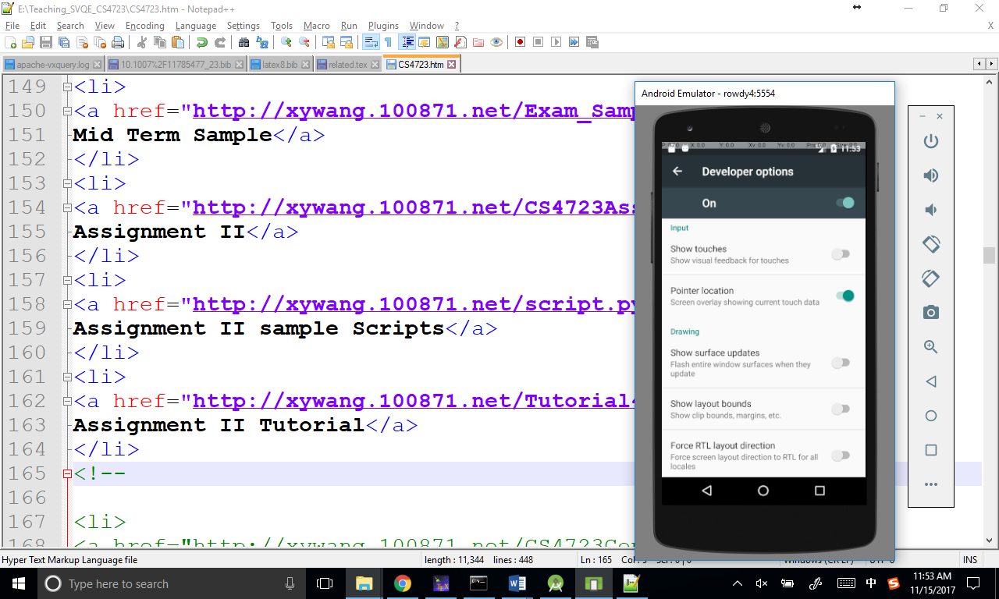

10. open cmd and go to the folder of Android home, you should find it at File->Project Structure
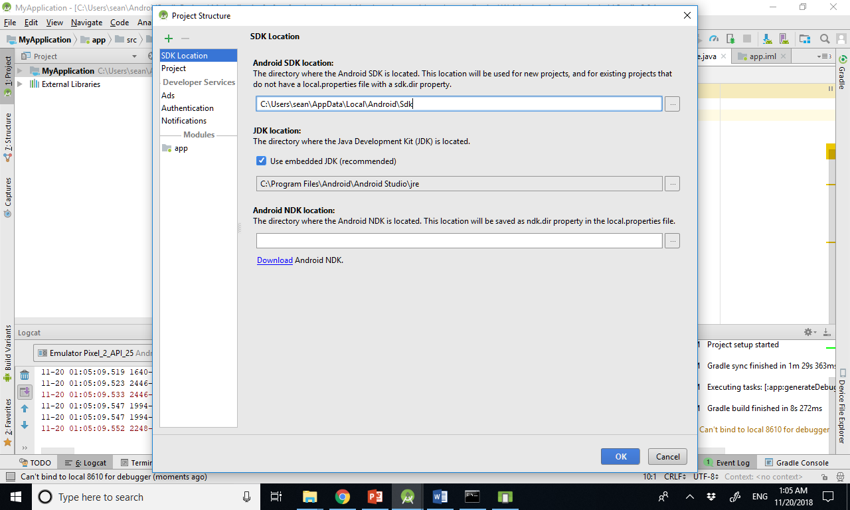

11. run monkeyrunner script.py, if you are using windows, please download the fixed monkey runner script from the course website.

